Introduction

Mo's Algorithm has become pretty popular in the past few years and is now considered as a pretty standard technique in the world of Competitive Programming. This blog will describe a method to generalize Mo's algorithm to maintain information about paths between nodes in a tree.

Prerequisites

Mo's Algorithm — If you do not know this yet, read this amazing [article](http://blog.anudeep2011.com/mos-algorithm/) before continuing with this blog.

Preorder Traversal or DFS Order of the Tree.

Problem 1 — Handling Subtree Queries

Consider the following problem. You will be given a rooted Tree *T* of *N* nodes where each node is associated with a value *A*[*node*]. You need to handle *Q* queries, each comprising one integer *u*. In each query you must report the number of distinct values in the subtree rooted at *u*. In other words, if you store all the values in the subtree rooted at *u* in a set, what would be the size of this set?

Constraints

1 ≤ *N*, *Q* ≤ 105

1 ≤ *A*[*node*] ≤ 109

Solution(s)

Seems pretty simple, doesn't it? One easy way to solve this is to flatten the tree into an array by doing a Preorder traversal and then implement Mo's Algorithm. Maintain a lookup table which maintains the frequency of each value in the current window. By maintaining this, the answer can be updated easily. The complexity of this algorithm would be http://codeforces.com/predownloaded/f5/cf/f5cfb6d16643eaf727724300cadeb654df0f4ea1.png

Note that you can also solve this in http://codeforces.com/predownloaded/5a/ac/5aacd2b5847ae17c98390cd30574a1fae41e41a7.png by maintaining a set in each node and merging the smaller set into the larger ones.

Problem 2 — Handling Path Queries

Now let's modify Problem 1 a little. Instead of computing the number of distinct values in a subtree, compute the number of distinct values in the unique path from *u* to *v*. I recommend you to pause here and try solving the problem for a while. The constraints of this problem are the same as Problem 1.

The Issue

An important reason why Problem (1) worked beautifully was because the dfs-order traversal made it possible to represent any subtree as a contiguous range in an array. Thus the problem was reduced to "finding number of distinct values in a subarray [*L*, *R*] of *A*[]. Note that it is not possible to do so for path queries, as nodes which are *O*(*N*) distance apart in the tree might be *O*(1) distance apart in the flattened tree (represented by Array *A*[]). So doing a normal dfs-order would not work out.

Observation(s)

Let a node *u* have *k* children. Let us number them as *v*1,*v*2...*vk*. Let *S*(*u*) denote the subtree rooted at *u*.

Let us assume that *dfs*() will visit *u*'*s* children in the order *v*1,*v*2...*vk*. Let *x* be any node in *S*(*vi*) and *y* be any node in *S*(*vj*) and let *i* < *j*. Notice that *dfs*(*y*) will be called only after *dfs*(*x*) has been completed and *S*(*x*) has been explored. Thus, before we call *dfs*(*y*), we would have entered and exited *S*(*x*). We will exploit this seemingly obvious property of *dfs*() to modify our existing algorithm and try to represent each query as a contiguous range in a flattened array.

Modified DFS-Order

Let us modify the dfs order as follows. For each node *u*, maintain the Start and End time of *S*(*u*). Let's call them *ST*(*u*) and *EN*(*u*). The only change you need to make is that you must increment the global timekeeping variable even when you finish traversing some subtree (*EN*(*u*) = ++*cur*). In short, we will maintain 2 values for each node *u*. One will denote the time when you entered *S*(*u*) and the other would denote the time when you exited *S*(*u*). Consider the tree in the picture. Given below are the *ST*() and *EN*() values of the nodes.

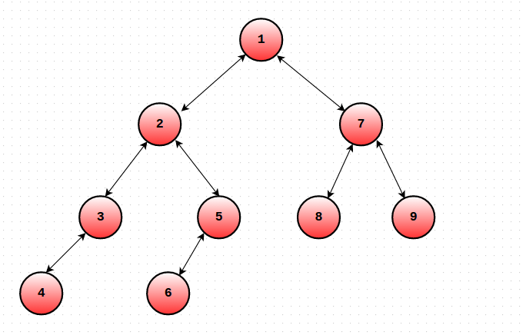

*ST*(1) = 1 *EN*(1) = 18

*ST*(2) = 2 *EN*(2) = 11

*ST*(3) = 3 *EN*(3) = 6

*ST*(4) = 4 *EN*(4) = 5

*ST*(5) = 7 *EN*(5) = 10

*ST*(6) = 8 *EN*(6) = 9

*ST*(7) = 12 *EN*(7) = 17

*ST*(8) = 13 *EN*(8) = 14

*ST*(9) = 15 *EN*(9) = 16

*A*[] = {1, 2, 3, 4, 4, 3, 5, 6, 6, 5, 2, 7, 8, 8, 9, 9, 7, 1}

The Algorithm

Now that we're equipped with the necessary weapons, let's understand how to process the queries.

Let a query be (*u*, *v*). We will try to map each query to a range in the flattened array. Let *ST*(*u*) ≤ *ST*(*v*) where *ST*(*u*) denotes visit time of node *u* in *T*. Let *P* = *LCA*(*u*, *v*) denote the lowest common ancestor of nodes *u* and *v*. There are 2 possible cases:

*Case* 1: *P* = *u*

In this case, our query range would be [*ST*(*u*), *ST*(*v*)]. Why will this work?

Consider any node *x* that does not lie in the (*u*, *v*) path.  
Notice that *x* occurs twice or zero times in our specified query range.   
Therefore, the nodes which occur exactly once in this range are precisely those that are on the (*u*, *v*) path! (Try to convince yourself of why this is true : It's all because of *dfs*() properties.)

This forms the crux of our algorithm. While implementing Mo's, our add/remove function needs to check the number of times a particular node appears in a range. If it occurs twice (or zero times), then we don't take it's value into account! This can be easily implemented while moving the left and right pointers.

*Case* 2: *P* ≠ *u*

In this case, our query range would be [*EN*(*u*), *ST*(*v*)] + [*ST*(*P*), *ST*(*P*)].

The same logic as Case 1 applies here as well. The only difference is that we need to consider the value of *P* i.e the LCA separately, as it would not be counted in the query range.

This same problem is available on [SPOJ](http://www.spoj.com/problems/COT2/).

If you aren't sure about some elements of this algorithm, take a look at this neat [code](http://ideone.com/6NVoPD).

Conclusion

We have effectively managed to reduce problem (2) to number of distinct values in a subarray by doing some careful bookkeeping. Now we can solve the problem in **O ( Q sqrt(N))**  This modified DFS order works brilliantly to handle any type path queries and works well with Mo's algo. We can use a similar approach to solve many types of path query problems.

For example, consider the question of finding number of inversions in a (*u*, *v*) path in a Tree *T*, where each node has a value associated with it. This can now be solved in http://codeforces.com/predownloaded/1a/12/1a1240cdd2f8ebef08a0237629921167f1d6a02f.png by using the above technique and maintaining a BIT or Segment Tree.

Sample Problems

1) [Count on a Tree II](http://www.spoj.com/problems/COT2/)   
2) [Frank Sinatra — Problem F](http://codeforces.com/gym/100962/attachments/download/4255/20152016-petrozavodsk-winter-training-camp-moscow-su-trinity-contest-en.pdf)   
3) [Vasya and Little Bear](https://www.codechef.com/ALKH2016/problems/VLB)